**System name :** Web partnermanage

**Short description :** สำหรับจัดการbanner ที่จะให้ partner นำไปแสดงที่หน้า web

**Url path (test) :**

จัดการข้อมูล Banner :  [http://192.168.0.2/v2/Administrator/WebPartner/SearchBanner.aspx](http://www.silkspan.com/v2/Administrator/WebPartner/SearchBanner.aspx)

จัดการข้อมูลขนาด Banner :  [http://192.168.0.2/v2/Administrator/WebPartner/SearchPropBanner.aspx](http://www.silkspan.com/v2/Administrator/WebPartner/SearchPropBanner.aspx)

จัดการ Textlink Banner :  [http://192.168.0.2/v2/Administrator/WebPartner/SearchLinkBanner.aspx](http://www.silkspan.com/v2/Administrator/WebPartner/SearchLinkBanner.aspx)

จัดการ Textlink Ads (group text) :  [http://192.168.0.2/banner/adstext/setup.asp?code=44](http://www.silkspan.com/banner/adstext/setup.asp?code=44)

Username = admin

Password = 1234

**Url path (production) :**

จัดการข้อมูล Banner : <http://www.silkspan.com/v2/Administrator/WebPartner/SearchBanner.aspx>

จัดการข้อมูลขนาด Banner : <http://www.silkspan.com/v2/Administrator/WebPartner/SearchPropBanner.aspx>

จัดการ Textlink Banner : <http://www.silkspan.com/v2/Administrator/WebPartner/SearchLinkBanner.aspx>

จัดการ Textlink Ads (group text) : <http://www.silkspan.com/banner/adstext/setup.asp?code=44>

Username = admin

Password = 1234

View Ads (Partner) : <http://silkspan.com/silkspan_ssl/partner/login.asp>

Username = sanook

Password = sanook

Sing-in web partner : <http://silkspan.com/silkspan_ssl/partner/signin.asp>

**Coding Path (production) :**

**ER diagram :**

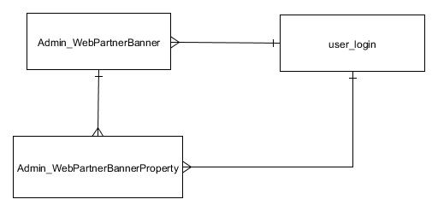

รูปภาพ ER diagram – จัดการข้อมูล Banner

| table name | description | relation | connectivity | remark |
| --- | --- | --- | --- | --- |
| Admin_WebPartnerBanner | เก็บข้อมูล master ของ banner ที่สร้าง, แก้ไขล่าสุด | User_login | many-to-one | สำหรับดึงข้อมูลผู้ใช้งาน ข้อมูลความสัมพันธ์ประกอบด้วย name |
| Admin_webPartnerProperty | one-to-many | สำหรับเก็บ property ของ banner ข้อมูลความสัมพันธ์ประกอบด้วย BannerSize  (= PropID ใน Admin_webPartnerProperty ) |

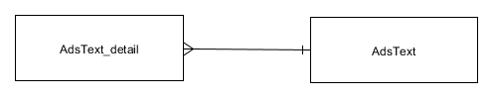

รูปภาพ ER diagram – จัดการ Ads group Text

| table name | description | relation | connectivity | remark |
| --- | --- | --- | --- | --- |
| AdsText | เก็บข้อมูล master ของ Ads ในรูปแบบ Text group ที่สร้าง, แก้ไขล่าสุด | AdsText_detail | one-to-many | สำหรับเก็บ Transaction ของ Ads ในรูปแบบ Text group ข้อมูลความสัมพันธ์ประกอบด้วย adsText_ID |

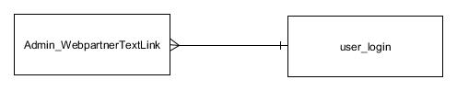

รูปภาพ ER diagram –จัดการ Ads Text

| table name | description | relation | connectivity | remark |
| --- | --- | --- | --- | --- |
| Admin_WebpartnerTextLink | เก็บข้อมูล transaction ของ Ads ประเภท Text Link ที่สร้าง, แก้ไขล่าสุด | User_login | Many-to-one | สำหรับดึงข้อมูลผู้ใช้งาน ข้อมูลความสัมพันธ์ประกอบด้วย name |

**Data dic** :

Table : Admin_WebPartnerBanner

|  |  |  |  |  |
| --- | --- | --- | --- | --- |
| Column name | Data type | Allow null | Description |  |
| Id | int | Unchecked |  | Pk |
| filePath | nvarchar(MAX) | Checked |  |  |
| numberDisplay | int | Checked |  |  |
| bannerType | nvarchar(50) | Checked |  |  |
| bannerSize | int | Checked |  | Fk |
| url | nvarchar(MAX) | Checked |  |  |
| createUser | nvarchar(100) | Checked |  |  |
| createDate | datetime | Checked |  |  |
| updateUser | nvarchar(100) | Checked |  |  |
| updateDate | datetime | Checked |  |  |

Table : Admin_webPartnerProperty

|  |  |  |  |  |
| --- | --- | --- | --- | --- |
| Column name | Data type | Allow null | Description |  |
| PropID | int | Unchecked |  | Pk |
| PropWidth | int | Checked |  |  |
| PropHeight | int | Checked |  |  |
| DispaySpeed | int | Checked |  |  |
| CreateUser | nvarchar(50) | Checked |  |  |
| CreateDate | datetime | Checked |  |  |
| UpdateUser | nvarchar(50) | Checked |  |  |
| UpdateDate | datetime | Checked |  |  |
| FlagHasProp | nvarchar(50) | Checked |  |  |

Table : AdsText

|  |  |  |  |  |
| --- | --- | --- | --- | --- |
| Column name | Data type | Allow null | Description |  |
| id | int | Checked |  | Pk |
| code | varchar(25) | Checked |  |  |
| name | varchar(25) | Checked |  |  |
| status | varchar(5) | Checked |  |  |
| width | int | Checked |  |  |
| height | int | Checked |  |  |
| alignment | varchar(5) | Checked |  |  |
| maxAds | int | Checked |  |  |

Table : AdsText_detail

|  |  |  |  |  |
| --- | --- | --- | --- | --- |
| Column name | Data type | Allow null | Description |  |
| id | int | Checked |  | Pk |
| name | varchar(25) | Checked |  |  |
| adsText_id | int | Checked |  | Fk |
| link | varchar(150) | Checked |  |  |
| parameter | varchar(150) | Checked |  |  |
| title | varchar(50) | Checked |  |  |
| detail | varchar(150) | Checked |  |  |
| status | varchar(5) | Checked |  |  |
| link_old | varchar(150) | Checked |  |  |

Table : Admin_WebpartnerTextLink

|  |  |  |  |  |
| --- | --- | --- | --- | --- |
| Column name | Data type | Allow null | Description |  |
| ID | int | Unchecked |  | Pk |
| Link | varchar(MAX) | Checked |  |  |
| BannerType | varchar(50) | Checked |  |  |
| CreateDate | datetime | Checked |  |  |
| CreateUser | varchar(50) | Checked |  |  |
| UpdateDate | datetime | Checked |  |  |
| UpdateUser | varchar(50) | Checked |  |  |
| Flag | varchar(50) | Checked |  |  |

Table : User_login

|  |  |  |  |  |
| --- | --- | --- | --- | --- |
| Column name | Data type | Allow null | Description |  |
| ID | int | Unchecked |  | Pk |
| NAME | varchar(50) | Checked |  | Fk |
| LNAME | varchar(50) | Checked |  |  |
| USERNAME | varchar(50) | Checked |  |  |
| PASSWORD | varchar(50) | Checked |  |  |
| USER_ROLE | varchar(50) | Checked |  |  |
| CREATE_USER | varchar(50) | Checked |  |  |
| CREATE_DATE | datetime | Checked |  |  |
| UPDATE_USER | varchar(50) | Checked |  |  |
| UPDATE_DATE | datetime | Checked |  |  |
| SYSTEM_NAME | varchar(50) | Checked |  |  |
| DEPARTMENT | varchar(50) | Checked |  |  |
| EMAIL | varchar(50) | Checked |  |  |
| STATUS | varchar(10) | Checked |  |  |
| CODE | int | Checked |  |  |
| MAIL_TYPE | varchar(50) | Checked |  |  |

**FAQ :**

Q1 = …..

A1 = ….

Screen

[Screen pic]

**Workflow** :

* Insert/Edit Banner

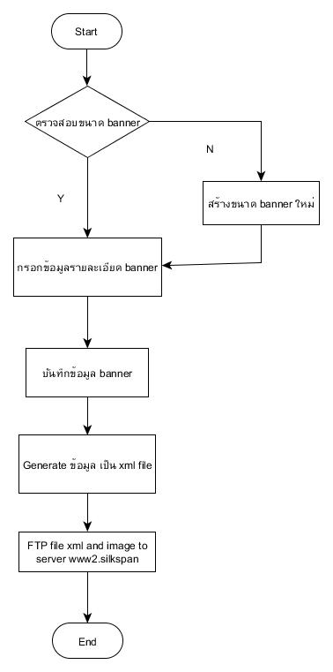

* View Banner

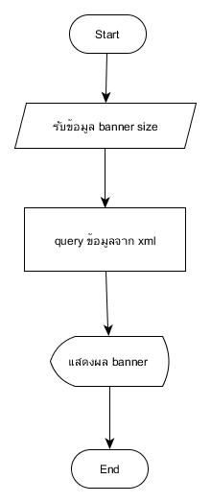

* Insert/Edit Ads group text link

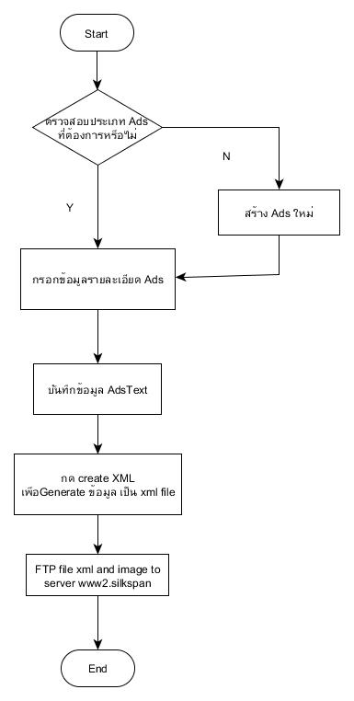

* Insert/Edit Ads text link

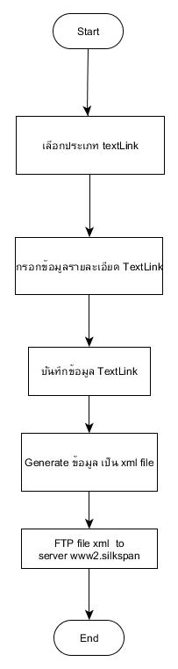

* View Ads text link

